Running the program will prompt a user input of “Number of students?”

For this example I used 25



Then, it will prompt the “Number of runs” to determine the probability of any 2 people sharing a birthday in the class

As the program runs, it will randomly generate different birthdays to check the probably of two-like birthdays

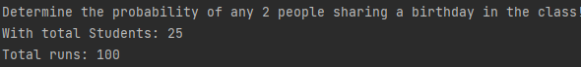



The result will be displayed at the bottom of the terminal

The result for this case would be 54% chance of any 2 people sharing a birthday in the class